Jack Johnson

September 1, 2021

Section End Project: Chatting with Socket IO

Link to my GitHub repository: <https://github.com/jjohn98/2058519_Jack_Johnson_Mean_Stack>

This project is located in ~/Phase3/Chatting Socket IO.

In this project, I created 2 files. The first file, chatHome.html, has the html code for the website as well as some basic JavaScript to handle sending and receiving messages to the server. The second file, server.js, has the backing JavaScript code using express and express-ws to run the server and send and receive messages to and from the client.

The home page is very basic and just has a form with name and message text inputs that take input from the user to be sent to the server when they click the “send message” button. Below the form, there is a list that will update with each new message sent to the server, then updates with the server’s response as well.

**List of inputs that have responses:**

Hi

Hello

how can i download google chrome?

how can i update my computer?

how can i turn on or off vibrate mode on my iphone?

why does the volume not work on my computer speakers?

how do i hook up a bluetooth device?

why isnt my printer working?

how do i add more storage to my computer?

All of these inputs can have any number of capital letters mixed in as they are ran through the .toLowerCase() function. The question mark at the end is required.

The files for this project will be in the GitHub repository, as well as the source code section of the submission on Simplilearn.

Screenshots of Webpage functionality:

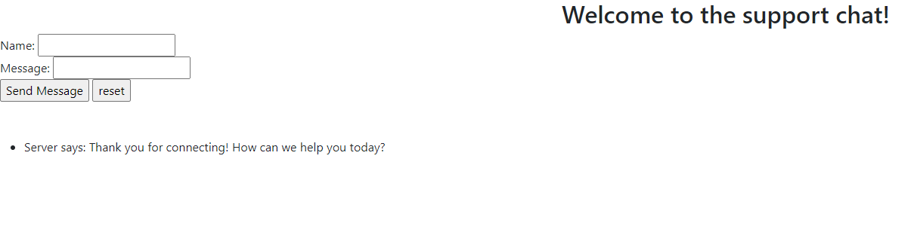

Hello input:

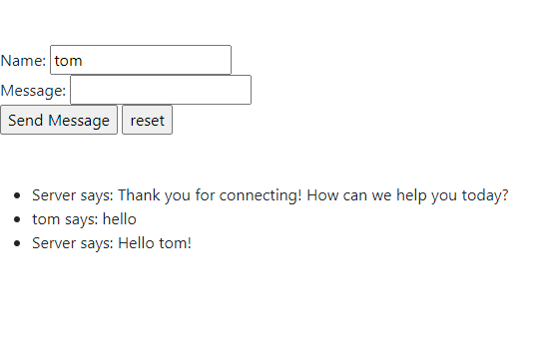

Bluetooth input before sending:

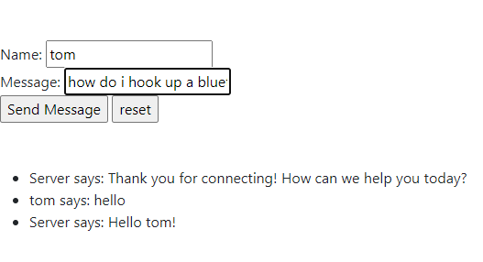

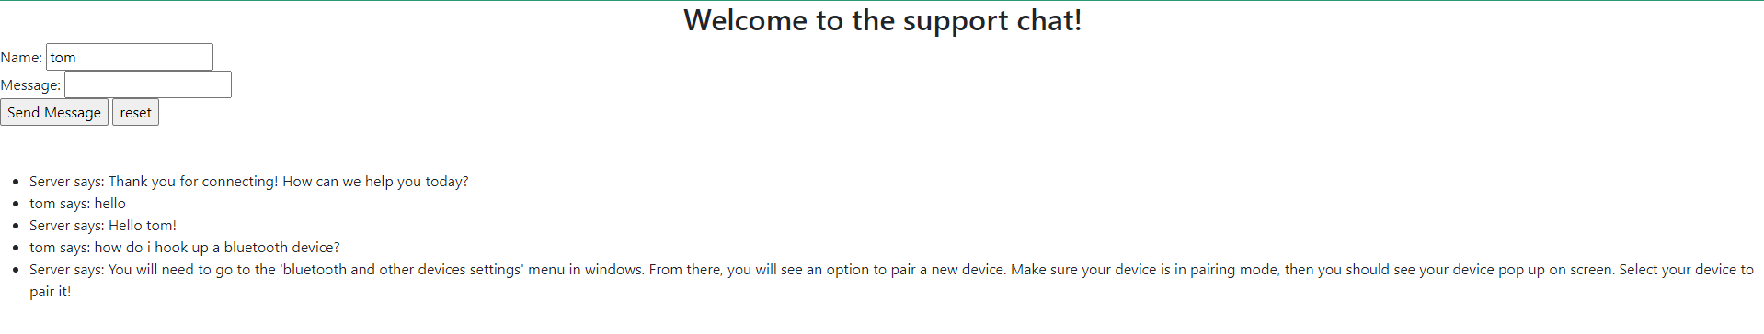Bluetooth input after sending:

**There are many other inputs as well you may try as listed previously!**

Server console:

